**5. Interface**  
**5.1 Component interface**

### **5.1.1 Module of User API**

|  |  |  |  |
| --- | --- | --- | --- |
| **Signature** | **Description** | **Output** | **Exception** |
| checkLogin(String username, String password) | Login into Web Application | JSON of user | JsonException |
| getUserById (int userId) | Fine user by Id | JSON of user | JsonException |
| getListUser () | Get all user | JSON of list user | JsonException |
| createUser (User user) | Create new user information | String | N/A |
| updateUser (User user) | Update user information | String | N/A |
| deleteUser(int userId) | Delete one user | String | N/A |
| activeUser(int userId) | Active user status | String | N/A |
| getUserByDepartment(int depId) | Get list user filter by department | JSON of list user | JsonException |

Table 12: Module of User API

### **5.1.2 Module of Department API**

|  |  |  |  |
| --- | --- | --- | --- |
| **Signature** | **Description** | **Output** | **Exception** |
| getListDepartment() | Get all department | JSON of department | JsonException |
| getDepartmentById(int depId) | Get department by Id | JSON of department | JsonException |
| createDepartment(Department department) | Create new department | String | N/A |
| updateDepartment(Department department) | Update one department | String | N/A |
| deleteDepartment(int depId) | Delete one department | String | N/A |

Table 13: Module of Department API

### **5.1.3 Module of Meeting API**

|  |  |  |  |
| --- | --- | --- | --- |
| **Signature** | **Description** | **Output** | **Exception** |
| getListMeeting() | Get all meeting | JSON of meeting | JsonException |
| getMeetingById (int id) | Get meeting by Id | JSON of meeting | JsonException |
| createMeeting(Meeting meeting) | Create new Meeting | String | N/A |
| updateMeeting (Meeting meeting) | Update one Meeting | String | N/A |
| getAllMeetingByUser (int userId) | Get all meeting of one user | JSON of meeting | JsonException |

Table 14: Module of Meeting API

### **5.1.4 Module of Mission API**

|  |  |  |  |
| --- | --- | --- | --- |
| **Signature** | **Description** | **Output** | **Exception** |
| getListMission() | Get all mission | JSON of mission | JsonException |
| getMissionById (int id) | Get mission by Id | JSON of mission | JsonException |
| createMission (Mission mission) | Create new mission | String | N/A |
| updateMission (Mission mission) | Update one mission | String | N/A |
| geAllMissionByUser (int userId) | Get all mission of one user | JSON of mission | JsonException |

Table 15: Module of Mission API

### **5.1.5 Module of Notification API**

|  |  |  |  |
| --- | --- | --- | --- |
| **Signature** | **Description** | **Output** | **Exception** |
| getListNotification() | Get all notification | JSON of notification | JsonException |
| getActivateNotification (int id) | Get all notification by Id | JSON of notification | JsonException |
| createNotification (Notification notification) | Create new notification | String | N/A |
| updateNotification (Notification notification) | Update one notification | String | N/A |
| getNotificationById (int notificationId) | Get all notification of one user | JSON of notification | JsonException |

Table 16: Module of Notification API

### **5.1.5 Module of Role API**

|  |  |  |  |
| --- | --- | --- | --- |
| **Signature** | **Description** | **Output** | **Exception** |
| getRoles() | Get all role | JSON of notification | JsonException |

Table 17: Module of Role API

### **5.1.6 Module of Room API**

|  |  |  |  |
| --- | --- | --- | --- |
| **Signature** | **Description** | **Output** | **Exception** |
| getListRoom() | Get all room information | JSON of room list | JsonException |
| getRoomById(int roomId) | Get room by id | JSON of room | JsonException |
| createRoom(Room room) | Create new room resource | String | N/A |
| updateRoom(Room room) | Update room information | String | N/A |

Table 18: Module of Room API

### **5.1.7 Module of Shift Scheduler Resource API**

|  |  |  |  |
| --- | --- | --- | --- |
| **Signature** | **Description** | **Output** | **Exception** |
| getListShiftSchedule() | Get list shift schedule | JSON of shift schedule | JsonException |
| getWaitingShiftSchedules() | Get shift schedule which stauts is waiting by id | JSON of shift schedule | JsonException |
| createShiftScheduler (ShiftSchedule scheduler) | Create new shift schedule | String | N/A |
| getShiftSchedulesByWeek (String week, int depId) | Get shift schedule is filtered by department and week | JSON of shift schedule | N/A |

Table 19: Module of Shift schedule API

**5.2User Interface Design**

**5.2.1 Web Application - Login**

**6. Database Design**  
**6.1 Entity relationship diagram (ERD)**

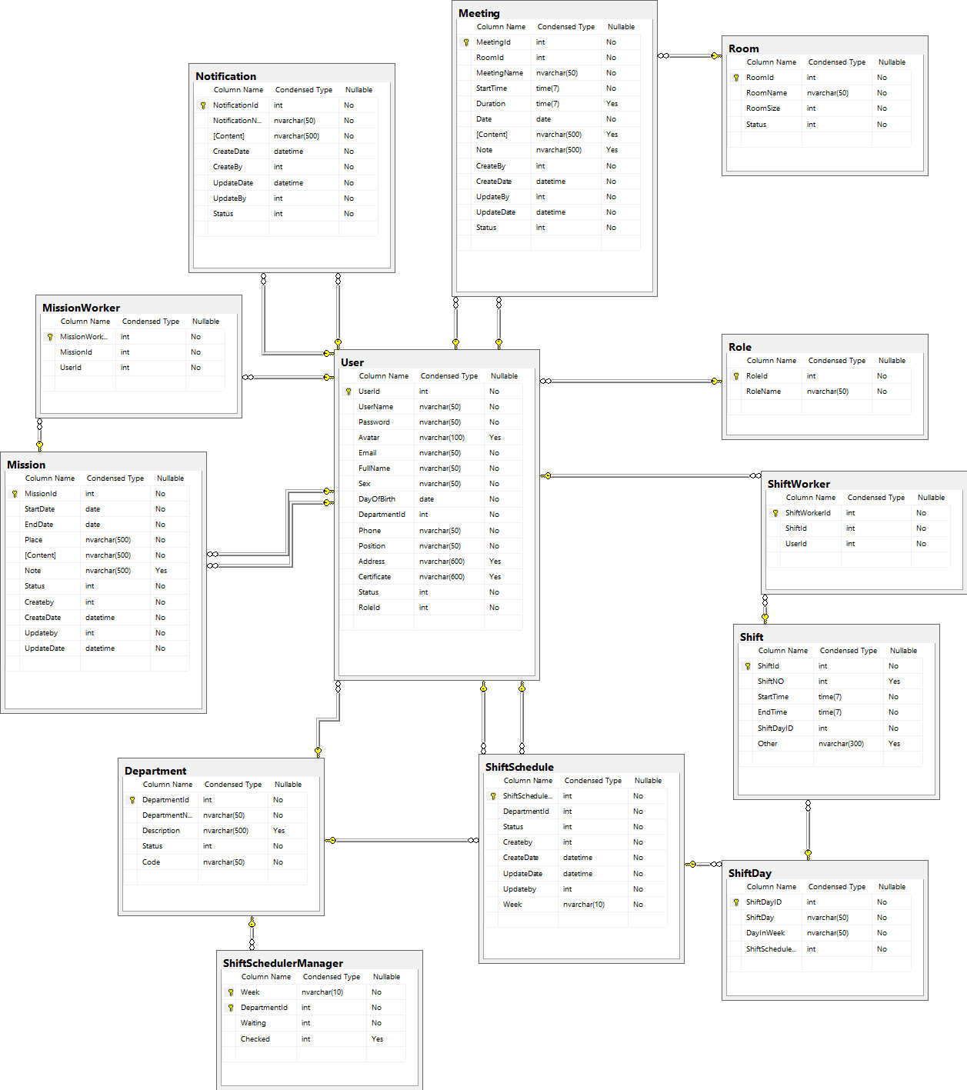

**6.2 Data Dictionary**

|  |  |
| --- | --- |
| **Entity Data dictionary: describe content of all entities** | |
| **Entity Name Description** | **Entity Name Description** |
| Department | Contain the department information. |
| Meeting | Contain the meeting information. |
| Mission | Contain the mission information. |
| MissionWorker | Contain the mission worker status. |
| Notification | Contain the notification information. |
| Role | Contain the role information. |
| Room | Contain the room information. |
| Shift | Contain the shift information. |
| ShiftDay | Contain the shift day information. |
| ShiftSchedule | Contain the shift schedule information. |
| ShiftScheduleManager | Contain the shift schedule manager information. |
| ShiftWorker | Contain the shift worker information. |
| User | Contain the user information. |

|  |  |  |  |  |
| --- | --- | --- | --- | --- |
| **Entity** | **Attributes** | **Description** | **Domain** | **Null** |
| Department | DepartmentId | Primary of department table | int | No |
| DepartmentName | Name of department | nvarchar(50) | No |
|  | Description | Description of department | nvarchar(500) | Yes |
|  | Status | Status of department | int | No |
|  | Code | Code of department | nvarchar(50) | No |

|  |  |  |  |  |
| --- | --- | --- | --- | --- |
| **Entity** | **Attributes** | **Description** | **Domain** | **Null** |
| Meeting | MeetingId | Primary of meeting table | int | No |
| RoomId | Room id of meeting | int | No |
|  | MeetingName | Name of meeting | nvarchar(50) | No |
|  | StartTime | Start time of meeting | Time(7) | No |
|  | Duration | Duration of meeting | Time(7) | Yes |
|  | Date | Date of meeting | date | No |
|  | Content | Content of meeting | nvarchar(500) | No |
|  | Note | Note of meeting | nvarchar(500) | Yes |
|  | CreateBy | Create by of meeting | int | No |
|  | CreateDate | Create date of meeting | date | No |
|  | UpdateBy | Update by of meeting | int | No |
|  | UpdateDate | Update date of meeting | date | No |
|  | Status | Status of meeting | int | No |

|  |  |  |  |  |
| --- | --- | --- | --- | --- |
| **Entity** | **Attributes** | **Description** | **Domain** | **Null** |
| Mission | MissionId | Primary of mission table | int | No |
| StartDate | Start date id of mission | date | No |
|  | EndDate | End date of mission | date | No |
|  | Place | Place of mission | nvarchar(500) | No |
|  | Content | Content of mission | nvarchar(500) | No |
|  | Note | Note of mission | nvarchar(500) | Yes |
|  | Status | Status of mission | int | No |
|  | Createby | Create by of mission | int | No |
|  | CreateDate | Create Date of mission | datetime | No |
|  | Updateby | Update by of mission | int | No |
|  | UpdateDate | Update Date of mission | datetime | No |

|  |  |  |  |  |
| --- | --- | --- | --- | --- |
| **Entity** | **Attributes** | **Description** | **Domain** | **Null** |
| MissionWorker | MissionWorkerId | Primary of mission worker table | int | No |
| MissionId | Primary of mission | int | No |
|  | UserId | Primary of user | int | No |

|  |  |  |  |  |
| --- | --- | --- | --- | --- |
| **Entity** | **Attributes** | **Description** | **Domain** | **Null** |
| Notification | NotificationId | Primary of notification table | int | No |
| NotificationName | Name of notification | nvarchar(50) | No |
|  | Content | Content of notification | nvarchar(500) | No |
|  | CreateDate | Create Date of notification | datetime | No |
|  | CreateBy | Create By of notification | int | No |
|  | UpdateDate | Update Date of notification | datetime | No |
|  | UpdateBy | Update By of notification | int | No |
|  | Status | Status of notification | int | No |

|  |  |  |  |  |
| --- | --- | --- | --- | --- |
| **Entity** | **Attributes** | **Description** | **Domain** | **Null** |
| Role | RoleId | Primary of role table | int | No |
| RoleName | Name of role | nvarchar(50) | No |

|  |  |  |  |  |
| --- | --- | --- | --- | --- |
| **Entity** | **Attributes** | **Description** | **Domain** | **Null** |
| Room | RoomId | Primary of room table | int | No |
| RoomName | Name of room | nvarchar(50) | No |
| RoomSize | Size of room | int | No |
| Status | Status of room | int | No |

|  |  |  |  |  |
| --- | --- | --- | --- | --- |
| **Entity** | **Attributes** | **Description** | **Domain** | **Null** |
| Shift | ShiftId | Primary of shift table | int | No |
| ShiftNo | No of shift | int | Yes |
| StartTime | Start Time of shift | Time(7) | No |
| EndTime | End Time of shift | Time(7) | No |
|  | ShiftDayId | Shift Day Id | int | No |
|  | Other | Note more about shift | nvarchar(300) | Yes |

|  |  |  |  |  |
| --- | --- | --- | --- | --- |
| **Entity** | **Attributes** | **Description** | **Domain** | **Null** |
| ShiftDay | ShiftDayId | Primary of Shift day table | int | No |
| ShiftDay | Day of shift | nvarchar(50) | Yes |
| DayInWeek | Day In Week | nvarchar(50) | No |
| ShiftScheduleId | Shift Schedule Id | int | No |

|  |  |  |  |  |
| --- | --- | --- | --- | --- |
| **Entity** | **Attributes** | **Description** | **Domain** | **Null** |
| ShiftSchedule | ShiftScheduleId | Primary of Shift Schedule table | int | No |
| DepartmentId | Department Id | int | No |
| Status | Status of Shift Schedule | int | No |
| Createby | Create by of Shift Schedule | int | No |
| CreateDate | Create Date of Shift Schedule | datetime | No |
| UpdateDate | Update Date of Shift Schedule | datetime | No |
| Updateby | Update by of Shift Schedule | int | No |
| Week | Week of Shift Schedule | nvarchar(10) | No |

|  |  |  |  |  |
| --- | --- | --- | --- | --- |
| **Entity** | **Attributes** | **Description** | **Domain** | **Null** |
| ShiftScheduleManager | Week | Week of Shift Schedule | int | No |
| DepartmentId | Department Id | int | No |
| Waiting | Status of Shift Schedule | int | No |
| Checked | Status by of Shift Schedule | int | Yes |

|  |  |  |  |  |
| --- | --- | --- | --- | --- |
| **Entity** | **Attributes** | **Description** | **Domain** | **Null** |
| ShiftWorker | ShiftWorkerId | Primary of Shift Worker table | int | No |
| ShiftId | Shift Id | int | No |
| UserId | User Id | int | No |

|  |  |  |  |  |
| --- | --- | --- | --- | --- |
| **Entity** | **Attributes** | **Description** | **Domain** | **Null** |
| User | UserId | Primary of user table | int | No |
| UserName | User Name of user | nvarchar(50) | No |
| Password | Password of user | nvarchar(50) | No |
|  | Avatar | Avatar of user | nvarchar(100) | Yes |
|  | Email | Email of user | nvarchar(50) |  |
|  | FullName | Full Name of user | nvarchar(50) |  |
|  | Sex | Sex of user | nvarchar(50) |  |
|  | DayOfBirth | Day Of Birth of user | date |  |
|  | DepartmentId | Department Id of user | int |  |
|  | Phone | Phone of user | nvarchar(50) |  |
|  | Position | Position of user | nvarchar(50) |  |
|  | Address | Address of user | nvarchar(600) | Yes |
|  | Certificate | Certificate of user | nvarchar(600) | Yes |
|  | Status | Status of user | int |  |
|  | RoleId | Role Id of user | int |  |

**7. Algorithms**

***7.1Document Breakdown***  
***7.1.1 Definition***

***7.1.2 Define Problem***

***7.1.3 Solution***

***7.1.4 Complexity***

***7.1.5 Flowchart***

***7.2 String Comparison***  
***7.2.1 Define Problem***

***7.2.2 Requirement***

***7.2.3 Solution***

***7.2.4 Example***

**E. System Implementation & Test**  
**1. Introduction**

**1.1 Overview**

This section provides in detail all necessary information about implementation information and testing procedure of Hospital Portal includes test plans, test cases, test result, test environments, pass, fail, criteria and risks estimations as well as a checklist to cover all possible cases.

**1.2 Test Approach**

* Goal: Test all features in the whole system based on the core flow.
* Method: black-box testing
* Technique: check list

The testing for this project will consists of unit test. Testing the program as a complete system to ensure that the software requirements have been met.

* Testing would be performed by all member of team and approved by team leader.
* System testing is focused on assessing the system’s reliability. This process is concerned with finding errors that result from unanticipated interactions between components and component interface problems.

**2. Database Relationship Diagram**  
**2.1 Physical Diagram**

**2.2 Data Dictionary**

**3. Performance Measures**

***3.1 Clustering Performance***

**4. Test Plan  
4.1 Features to be tested**

- Admin: Login, create user, update user, active/deactivate user, create department, update department, active/deactivate department, create room, update room, active/deactivate room

- Manager: create mission schedule, update mission schedule, active/deactivate mission schedule, create meeting schedule, update meeting schedule, active/deactivate meeting schedule, create notification, update notification, active/deactivate notification

- User: Search meeting schedule

**4.2 Features not to be tested**

- Manager: Send SMS to employee

- User: View mission schedule, view meeting schedule, view shift schedule, view notification

**5. System Testing Test Case**

***5.1 Guest Test Case***